**CS689 Assignment 3**

Q. Explain elapsed date dimension

This is a date-time dimension which is based on the intervals between one or more dates. This dimension is useful to find out since how long an employee has been employed. There is no usage of absolute dates in this dimension.

Q. How does the pay_change_facts table refer to each dimension.

First indexes are created on each of the individual dimension tables and then these indexes are used as foreign key reference in the fact table using the following column names:

Employee_dimension 🡪 Employee_key

Location_dimension 🡪 location_key

Calendar_dimension 🡪 calender_key

Elapsed_days_dimension 🡪 day_key

Department_dimension 🡪 department_key

The alter command at the end of the script is what makes these foreign key constraints available.

I opened up data grip and found out this star schema layout which shows all the references made.

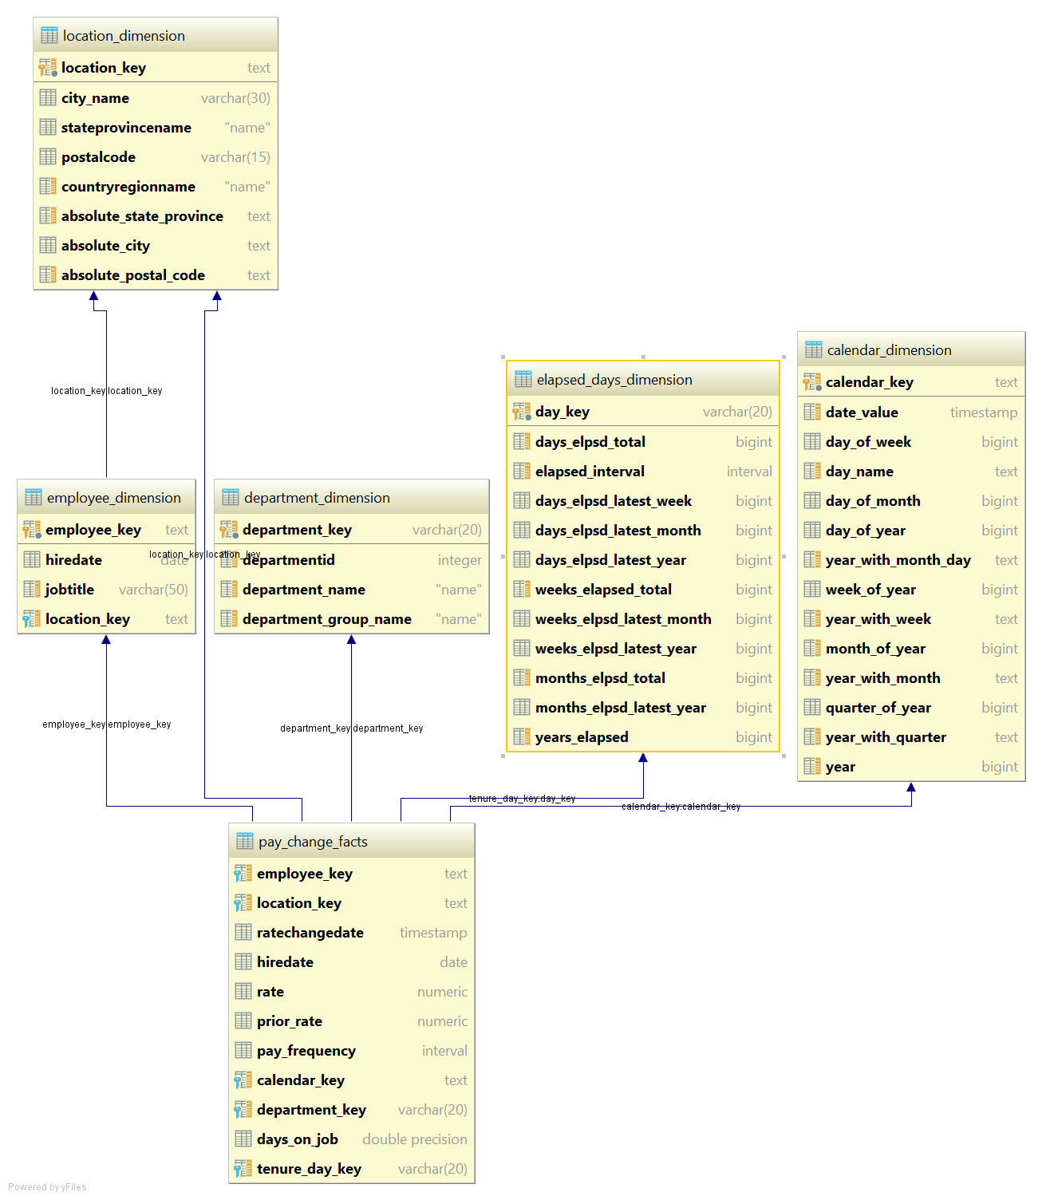

Q. Run each query in the script **when\_are\_there\_pay_changes.sql**. Examine the results. What do the queries tell us about pay changes?

Query 1:

The query calculates and groups number of employees based on ratechangeddate > hireddate, assuming rate change date is the date when he got a raise on salary. Calculates the number of employees who have received the rate change corresponding to the total number of months elapsed it took to get that rate change.

Query 2:

Does the same job as above but instead of number of months, it uses the months elapsed from latest year field in order to GROUP BY.